Contents
Systems of Linear Equations 2
“I Can” Do Math (Expressions & Equations) 3
I can analyze and solve linear equations and pairs of simultaneous 3
M4 L24 Solving Systems of Linear Equations by Graphing 4
M4 L24 Solving Systems of Linear Equations by Graphing CW 6
M4 L26 Solving Systems of Linear Equations by Substitution 9
M4 L26 Solving Systems of Linear Equations by Substitution ET 13
1. 13
M4 L17 Part 2 Rewrite Standard Form Notes Error! Bookmark not defined.
M4 L17 Part 2 Rewrite Standard Form Classwork Error! Bookmark not defined.
M4 L17 Rewrite Standard Form Exit Ticket 17
M4 L18 Graphing a line from the slope-intercept form 18
M4 L18 Graphing a line from the slope-intercept form CW 20
M4 L18 Graphing a line from the slope-intercept form Exit Ticket Error! Bookmark not defined.
M4 L19 Graphing by finding the x and y-intercepts Error! Bookmark not defined.
M4 L19 Classwork Error! Bookmark not defined.
M4 L19 Graphing by finding the x and y-intercepts Exit Ticket Error! Bookmark not defined.
M4 L20 Create Equation from a Graph Notes Error! Bookmark not defined.
M4 L20 Classwork 1 Error! Bookmark not defined.
M4 L20 Create Equation from a Graph Exit Ticket Error! Bookmark not defined.
M4 L21 Using Slope to Form an Equation Notes Error! Bookmark not defined.
M4 L21 Using Slope to Form an Equation CW Error! Bookmark not defined.
M4 L21 Using Slope to Form an Equation Exit Ticket Error! Bookmark not defined.
M4 L22 Constant Rates Revisited Notes Error! Bookmark not defined.
M4 L22 Constant Rates Revisited CW 11/13/2018 Error! Bookmark not defined.
M4 L22 Constant Rates Revisited Exit Ticket Error! Bookmark not defined.

Standards: 8.EE.8
Module 4
Topic D
Lesson 24-30

Systems of Linear Equations

“I Can” Do Math (Expressions & Equations)

I can analyze and solve linear equations and pairs of simultaneous
linear equations.
ο 8.EE.8a I can identify cases in which a system of two equations in two unknowns has no solution or an infinite number of solutions.
ο 8.EE.8b I can solve simple cases of systems of two linear equations in two variables.
ο 8.EE.8c I can solve real-world and mathematical problems leading to two linear equations in two variables.

M4 L24 Solving Systems of Linear Equations by Graphing Notebook p.76
8.EE.C.8a Understand that solutions to a system of two linear equations in two variables correspond to points of intersection of their graphs, because points of intersection satisfy both equations simultaneously.
Learning Target: _______________________________________________________________
_____________________________________________________________________________
Your family starts a bed-and-breakfast. It spends $500 fixing up a bedroom to rent. The cost for food and utilities is $10 per night. Your family charges $60 per night to rent the bedroom.
- Write an equation that represents the costs.

- Write an equation that represents the revenue (income).
- A set of two (or more) linear equations is called a system of linear equations. Write the system of linear equations for this problem.

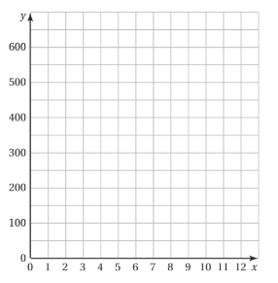
- Graph the cost equation.
- Graph the revenue equation.
- Find the point of intersection of the two graphs.
What does this point represent?

- ________________________________________ is a set of two or more linear equations in the same variables.
- A ________________of a system of linear equations in two variables is an
_______________________ that is a solution of each equation in the system.
- The solution of a system of linear equations is the
____________________________________ of the graphs of the equations.

M4 L24 Solving Systems of Linear Equations by Graphing Notebook p.77
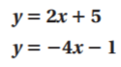
Example 2 (both equations are in slope-intercept form):

Solve the system by graphing.
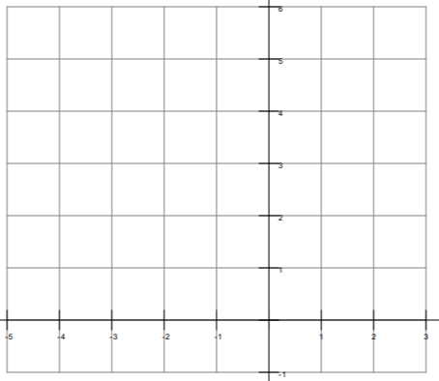
Steps:
① Graph each equation.
② Name the point of intersection.
③ Check the point from Step 2

Example 3 (one of the equations is in standard form):
Go back to notebook p.67 Lesson 19 notes.
Sketch the graphs of the linear system on a coordinate plane: $\left\{\begin{aligned}2y+x=12 \\ y=\frac{5}{6}x-2 \end{aligned}\right.$
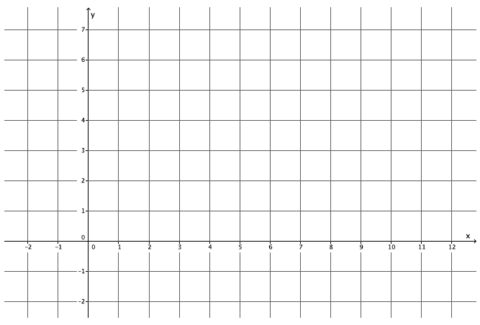
Steps:
① Graph each equation.
Standard Form: use ______________
② Name the point of intersection.
③ Check the point from Step 2

M4 L24 Solving Systems of Linear Equations by Graphing CW 11/14/2018
Partner A Name : ____________________________________ Partner B Name:___________________________________
Exercises 1
Do: Partner A ; Assist Partner B
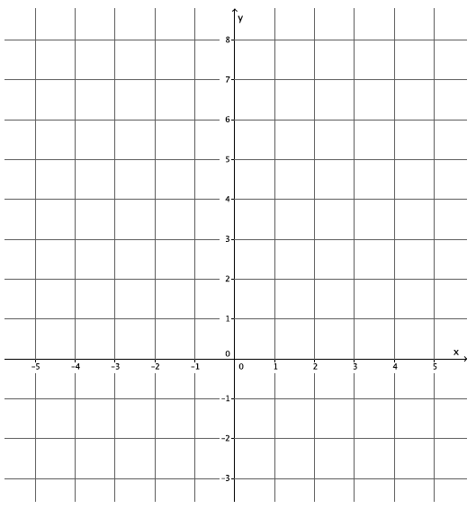
Sketch the graphs of the linear system on a coordinate plane:
$\left\{\begin{aligned}x+y=-2 \\ y=4x+3 \end{aligned}\right.$.

① Graph each equation.
Standard Form: use ______________
② Name the point of intersection.
③ Check the point from Step 2

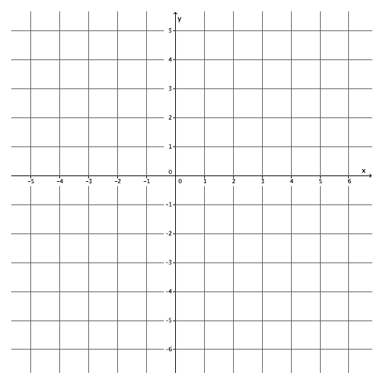
Exercises 2
Do: Partner B ; Assist Partner A
Sketch the graphs of the linear system on a coordinate plane:
$\left\{\begin{aligned}3x+y=-3 \\ -2x+y=2\end{aligned}\right.$.

① Graph each equation.
Standard Form: use ______________
② Name the point of intersection.
③ Check the point from Step 2

M4 L24 Solving Systems of Linear Equations by Graphing CW 11/14/2018
Homework:
- Sketch the graphs of the linear system on a coordinate plane:
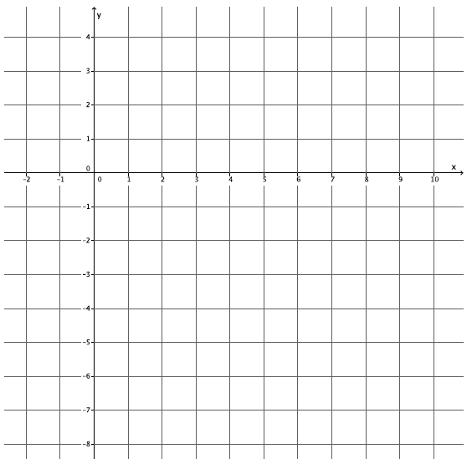
$\left\{\begin{aligned}2x-3y=18 \\ 2x+y=2 \end{aligned}\right..$

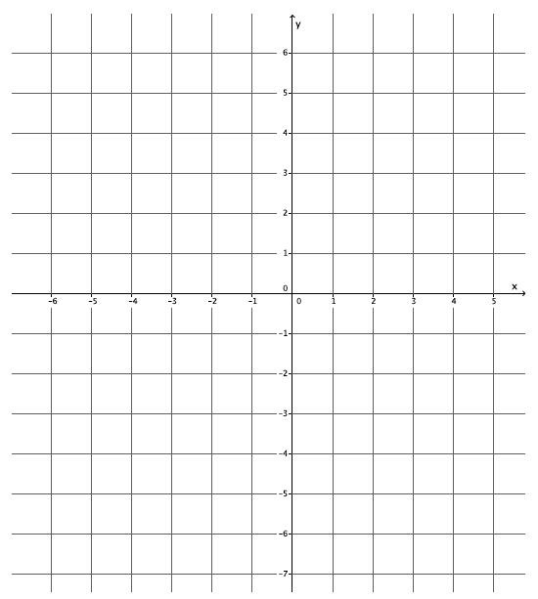
- Sketch the graphs of the linear system on a coordinate plane:
$\left\{\begin{aligned}y-x=3 \\ y=-4x-2\end{aligned}\right.$.

M4 L24 Solving Systems of Linear Equations by Graphing ET 11/14/2018
Name:________________________ Cohort: _____
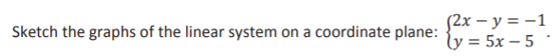
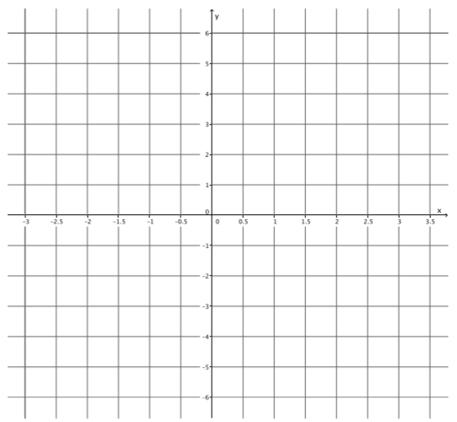

M4 L26 Solving Systems of Linear Equations by Substitution Notebook p.78
8.EE.C.8a Understand that solutions to a system of two linear equations in two variables correspond to points of intersection of their graphs, because points of intersection satisfy both equations simultaneously.
Learning Target: _______________________________________________________________
_____________________________________________________________________________
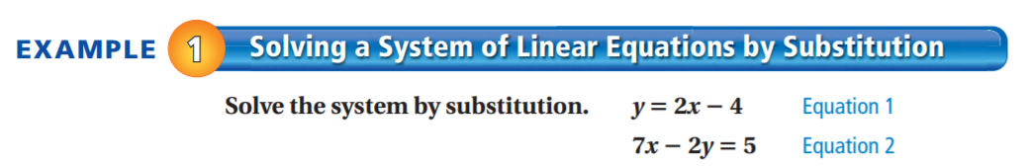
① Solve a variable by itself.
Equation ______ is already solved for ____ .
② Substitute y = 2x – 4 into Equation 2
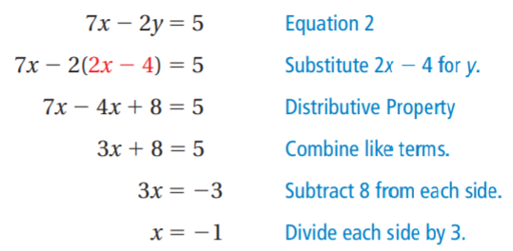
③ Substitute x into Equation 1 to solve for y.
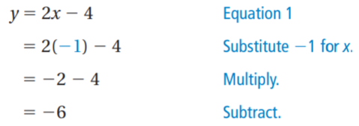

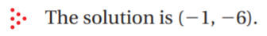
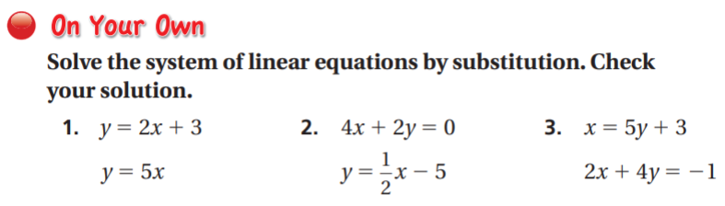
M4 L26 Solving Systems of Linear Equations by Substitution Notebook p.79
You buy a total of 50 turkey burgers and veggie burgers for $90. You pay $2 per turkey burger and $1.50 per veggie burger.
Write and solve a system of linear equations to find the number x of turkey burgers and the number y of veggie burgers you buy.
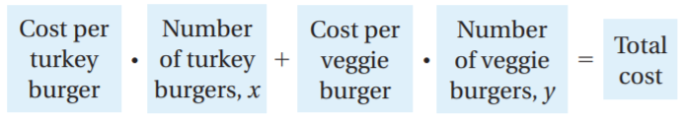
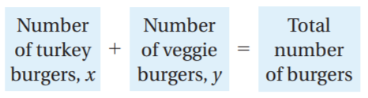

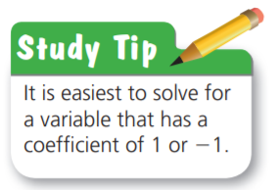
The system is:
① Solve a variable by itself.

② Substitute and solve ③ Substitute and solve

M4 L26 Solving Systems of Linear Equations by Substitution CW 11/16/2018
Partner A Name : ____________________________________ Partner B Name:___________________________________
Exercise 1
Do: Partner B ; Assist Partner A
You sell lemonade for $2 per cup and orange juice for $3 per cup. You sell a total of 100 cups for $240.
Write and solve a system of linear equations to find the number of cups of lemonade and the number of cups of orange juice you sold.

Exercise 2
Do: Partner A ; Assist Partner B
A weightlifter uses a total of 12 plates to add 260 pounds to a bar. He uses 45-pound plates and 10-pound plates.
Write and solve a system of equations to find the number x of 45-pound plates and the number y of 10-pound plates he uses.

M4 L26 Solving Systems of Linear Equations by Substitution CW 11/16/2018
Name:___________________________________ Cohort:_______________

Independent Practice:
      - Solve the system of equation by substitution.
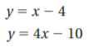

      - SCHOOL CLUBS - There are a total of 64 students in a drama club and a yearbook club. The drama club has 10 more students than the yearbook club.
a. Write a system of linear equations that represents this situation.
b. How many students are in the drama club? The yearbook club?

M4 L26 Solving Systems of Linear Equations by Substitution ET 11/16/2018
Name:___________________________________ Cohort:_______________

1. A drama club earns $1040 from a production. It sells a total of 64 adult tickets and 132 student tickets. An adult ticket costs twice as much as a student ticket.

a. Write a system of linear equations that represents this situation.
b. What is the cost of each ticket?

M4 L27 Solving Systems of Linear Equations by Elimination Notebook p.80
8.EE.8b Solve systems of two linear equations in two variables algebraically, and estimate solutions by graphing the equations. Solve simple cases by inspection.
8.EE.8c Solve real-world and mathematical problems leading to two linear equations in two variables.
Learning Target: _______________________________________________________________
_____________________________________________________________________________
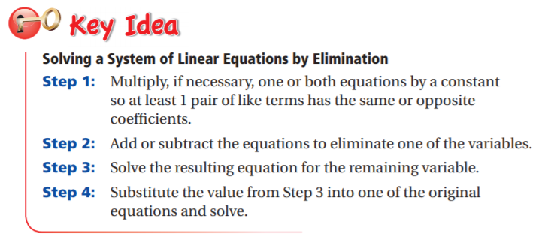
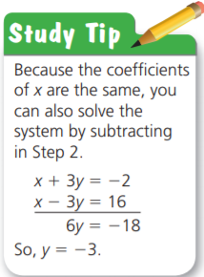
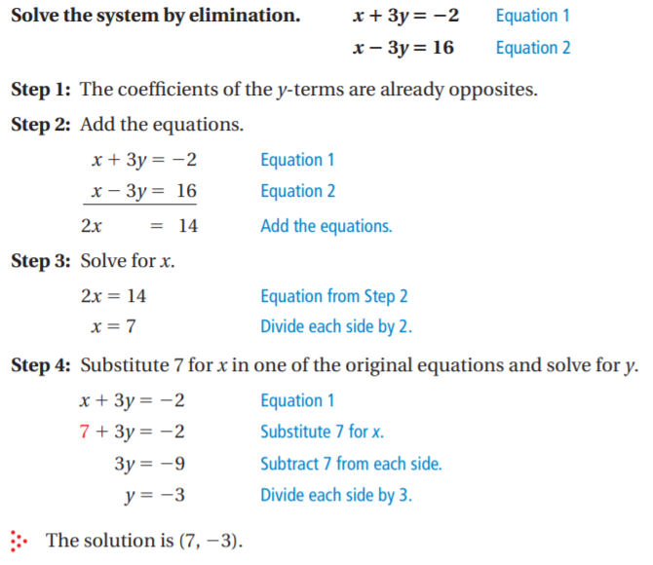

M4 L27 Solving Systems of Linear Equations by Elimination Notebook p.81
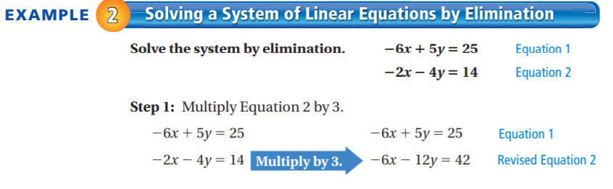
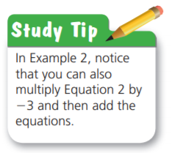
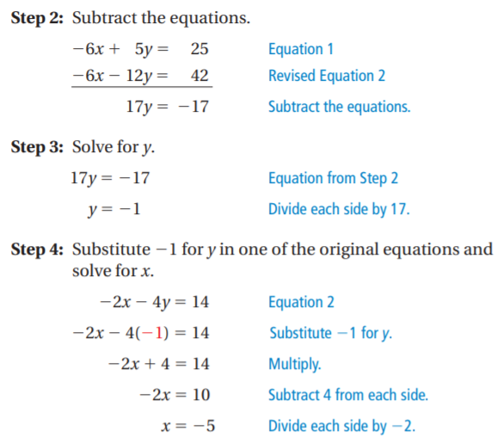

M4 L27 Solving Systems of Linear Equations by Elimination CW 11/19/2018
Partner A Name : ____________________________________ Partner B Name:___________________________________
Exercises 1-3
Do: Partner A ; Assist Partner B
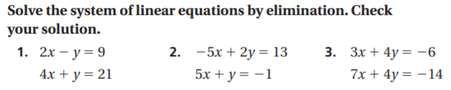

M4 L27 Solving Systems of Linear Equations by Elimination CW 11/19/2018
Partner A Name : ____________________________________ Partner B Name:___________________________________
Exercises 4-6
Do: Partner B ; Assist Partner A
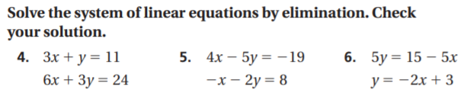
M4 L27 Solving Systems of Linear Equations by Elimination Exit Ticket Name:___________________________ Cohort:______ 11/19/2018

M4 L28 Solving Systems of Linear Equations by Elimination Notebook p.82
8.EE.8b Solve systems of two linear equations in two variables algebraically, and estimate solutions by graphing the equations. Solve simple cases by inspection.
8.EE.8c Solve real-world and mathematical problems leading to two linear equations in two variables.
Learning Target: _______________________________________________________________
_____________________________________________________________________________
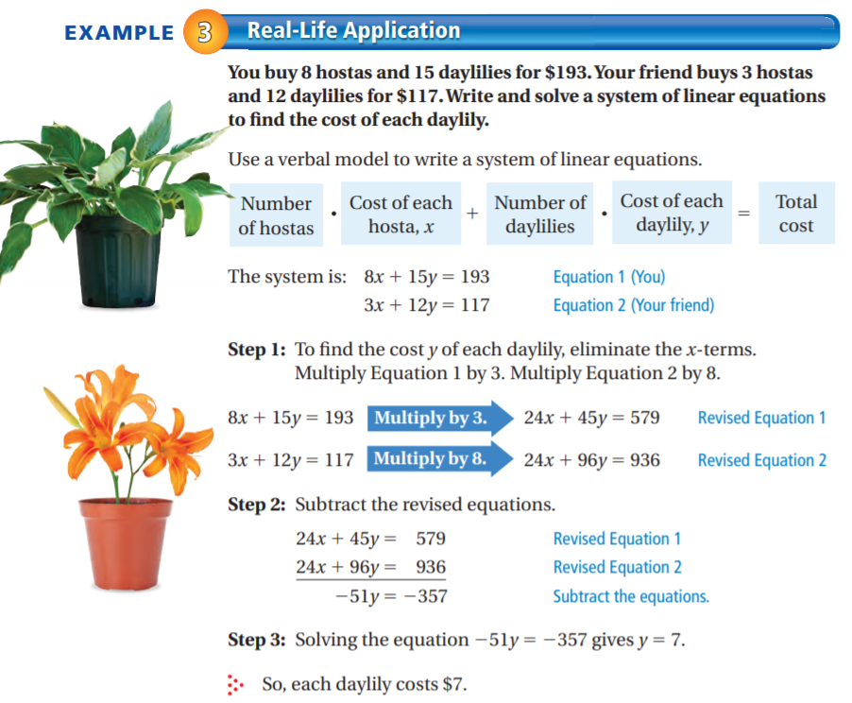
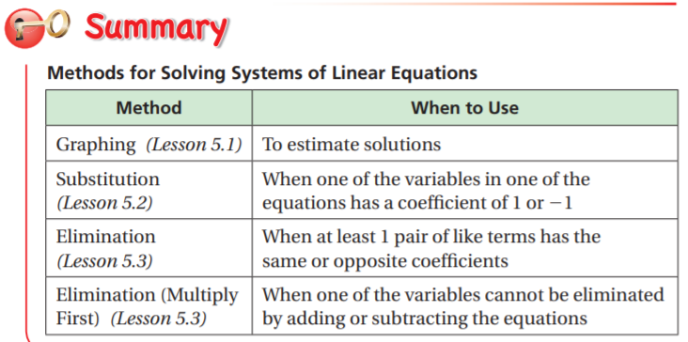
M4 L28 Solving Systems of Linear Equations by Elimination Notebook p.83
Example 4:
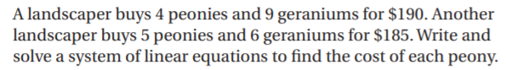

M4 L28 Solving Systems of Linear Equations by Elimination CW 11/21/2018

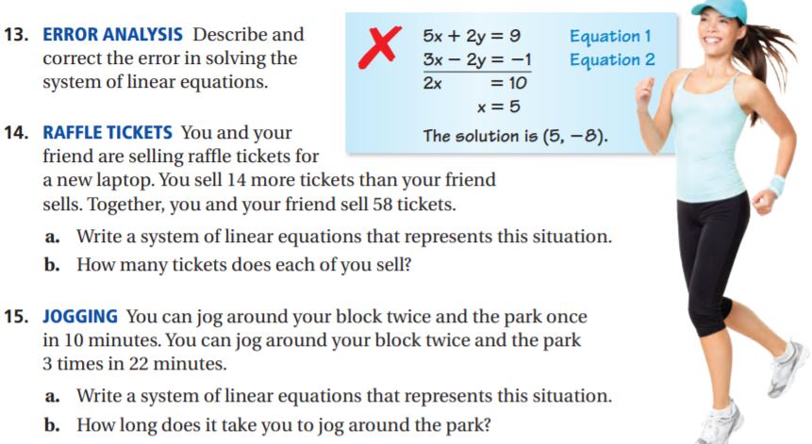
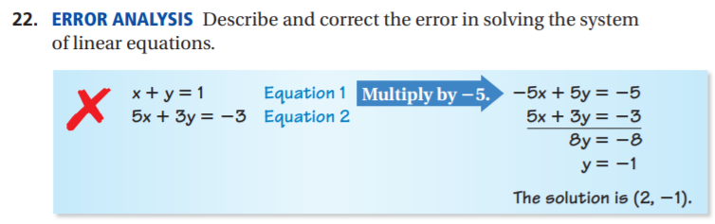

M4 L28 Solving Systems of Linear Equations by Elimination CW 11/21/2018
Partner A Name : ____________________________________ Partner B Name:___________________________________
Exercises 13, 15 Exercises 14, 22
Do: Partner B ; Assist Partner A Do: Partner A ; Assist Partner B
13. | 14.
15. | 22.
M4 L28 Solving Systems of Linear Equations by Elimination ET 11/21/2018
Name:__________________ Cohort:_______
Exit Ticket

